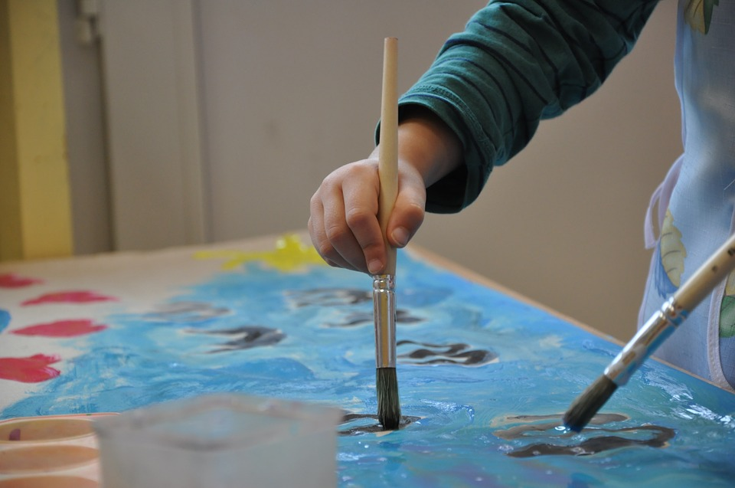
Photo credit: Pixabay

5 Simple Ways You Can Help Special Needs Children Enjoy the Arts

Art can be a wonderful way for children to develop their minds and get creative. For children with learning disabilities and special needs and their parents, art can provide a much-needed relief from stress and tension. If you want to help your child get in touch with their creative side, start with these five tips.

Invest in Some Startup Supplies

If you want to help your kid get creative, you’ll need to start with a good art kit. Look for items that will make creativity easy for children with special needs. Jumbo markers and large pencils are a good choice for children with learning disabilities. It’s a good idea to pick up some large sheets of paper as well, and don’t forget to grab an apron! Kids tend to get messy with art (and that’s honestly half the fun), and an apron will help keep clothes clean. Better yet, set aside some old clothes for use when painting and drawing.

Help Them Stay Calm While Creating

Art can be fun, but getting creative can cause some children to become overly excited or frustrated. Find ways to keep your child relaxed while exploring their inner artist. Play some soothing music in the background or use calming scents like lavender during these imagination sessions. Monitor your little artist for signs of stress so you can address frustrations before they blow up into bigger issues.

Organize a Stress-Free Space

If you or your child are worried about spills and messes, it can put a real damper on the stress-relieving, fun effects of art. To ease your worries, think about putting together a dedicated art room or creative space in your house. Try to choose an area free of carpet, or cover carpeting with cheap, replaceable mats or rugs. If you’re worried about marks on walls, there are plenty of stain-resistant paints that are easy to clean. You can even think about using chalk paint on the walls and letting children truly unleash their creative energies. Set up some easels and a few chairs to keep your creative genius comfortable, and don’t forget to use calming lighting.

Focus on the Fun, Not The Outcome

Creating art should be all about the process, not the product, so allow your child full creative freedom to paint, sculpt or draw as he/she pleases. Offer plenty of praise when you see your child engaged and having fun, and try to avoid helping out or critiquing too much. Many children on the spectrum or with emotional disabilities can be pretty hard on themselves. If your child seems overly focused on perfection or doesn’t seem relaxed, have them take a break, and talk to them about their concerns.

Discover Different Kinds of Art for Different Needs.

Different kids have different abilities and needs, so it’s important to find a level of art that fits those of your child. Children with tactile or sensory issues may benefit from specialized art projects rather than general painting and drawing. Mix food coloring with water and allow your child to safely explore the mixtures, or have your child paint with a plastic storage bag so they don’t have to get messy right away. There are so many wonderful ways to ease a child into getting creative, and the positive benefits creativity brings to their life are nearly endless.

Creative hobbies like painting and sculpting create opportunities for children with learning disabilities to relax while expressing their imagination. Art is a great tool for coping with stress and emotions during childhood and even as an adult, so help your child connect with their creative side. With a few modifications and careful considerations, any child can enjoy the benefits and freedom of the arts.

